**An Analysis of Wildlife Strikes on Aircrafts**

Jagroop Singh

Department of Computer Science

University of Windsor, Windsor

ON, Canada

Singh1pd@uwindsor.caShubhdeep Kaur

Department of Computer science

University of Windsor, Windsor

ON, Canada.

kaur16i@uwindsor.caGagandeep Singh Saini

Department of Computer Science,

University of Windsor, Windsor

ON, Canada.

saini12a@uwindsor.ca

**ABSTRACT**

**United States of America has one of the busiest airspace with respect to the commercial aircrafts. According to Federal Aviation Administration(FAA) there are over 42700 flights that crisscross the American airspace on an average, and this number increases in the holiday season. These flights are not always safe and sound there are miss-happening that can happen due to various reasons which could be weather, technical fault, wildlife strike, etc. These miss-happening cause damage which is financial as well as could turn out to be fatal. Wildlife strikes has been really a big problem for commercial planes, they cause damage to the plane as well result in delay of flights and sometimes cancellation also. We have gathered data for 711 airports pan United states and tried to find out the reasons behind the damage and how much this damage could cost. The aircrafts that we dealt with in our data are all commercial but of different sizes. So, we tried to understand the behavior of the strikes like at what altitude they occur and at what phase of flight do they occur. The data that we have used is from the year 2000 to 2015. Overall, there has been a steady increase in the number of strikes year on year. Moreover, there could be many instances that would not have been reported. Thus, considering only the available data we need to design some safety measures.**

***Keywords- Wildlife strikes, Federal Aviation Administration(FAA), safety measures.***

1. Introduction

The first reported bird strike was by Orville Wright in 1905. According to the Wright Brothers' diaries, "Orville … flew 4,751 meters in 4 minutes 45 seconds, four complete circles. Twice passed over fence into Beard's cornfield. Chased flock of birds for two rounds and killed one which fell on top of the upper surface and after a time fell off when swinging a sharp curve [1]. Ever since then there has been increase in the number of incidents that have been reported, since 1990 Federal Aviation Administration(FAA) has been reported to about these incidents and many attempts have been made to bring down the number of incidents. Since the time man is able to fly there has been increase in the number of airplanes be it for the army purpose or for commercial purpose. This increase has number of accidents that are happening. For the given time duration (2000-2015) there has been a report of about 28200 incidents and these incidents have been both in the airplanes and helicopters although these strikes reported are not generally detailed like in many cases the financial loss has not been detailed properly. Now dealing with data we came across multiple types of wildlife that have damaged the aircrafts these could be broadly divided into birds, terrestrial animals. These can be further sub divided into categories of type of animals and birds like alligators, deer’s etc. Although the reporting of the number of incidents that took place due to the terrestrial animals is less but due to their size they can cause considerably huge damage. The bird that has been reported to be the part of most number of incidents is Mourning Dove, followed by Gulls. But on the contrary the amount of damage reported is highest for the damage caused by the Canada Goose.

While working on the data it has been initially found out that the number of strikes that took place was highest in the season of fall and lowest in the summer season. The trend can also be seen of the time of day when the strikes are highest in number and when they are lowest in number. Like for the data we got the number of strikes are highest in day time and lowest in dusk and dawn conditions. Next when we try to find out the states that have maximum number of incidents reported we discovered that California tops in this case. While the strikes happen, there were many cases in which the flights were not affected but in some flights, were not able to take-off and in some flights had to be landed for the precautionary reasons. All the incidents that have been reported completely showed that the flight had to go out of service for the repair purposes and this effects the flight schedules and cost while the damage by birds caused maximum time off for the aircrafts but the damage by terrestrial mammals has also been very costly in this aspect. The data has been used to find out what exactly causes these patterns and what could be the possible solution to bring down this number.

1. Data Collection

The Data for the wildlife strikes is easily accessible from FAA’s website where the data has been already processed but for our data analysis we got the data from the sample data present on the website of Tableau i.e. www.public.tableau.com where the data has been processed and a single Excel file has been created, this file has the data taken from the same FAA’s website mentioned earlier.

The data that has been collected on the website is done as a voluntary work, anyone can report an incident be it a pilot or a passenger. The data is then validated into the table and this can be used to update the tables that you already have with the new rows that have been added. Most (65 percent) of the 66,392 strike reports were filed using the paper (53 percent) or electronic (12 percent) version of FAA Form 5200-7, Bird/Other Wildlife Strike Report. Since the online version of this form became available in April 2001, use of the electronic reporting system has climbed dramatically. In 2005, 38 percent of the strike reports were submitted electronically [2].

1. **Data Understanding**

The data set that we have used for our data analysis has the list of 711 airports that have been spread through-out the United States. This data set uses only the commercial aircrafts it can be divided into helicopters and airplanes which have been classified upon the number of engines that the planes use. Then we have the geographical locations of the airports that is their longitudes and latitudes this is very useful when used with right data analysis tool, this makes the representation of data easy and convenient for audience to understand. Next up we have the data regarding the time of flight and day, what it tells is that, the time of day tells at what part of day i.e. day, dusk, dawn, night. Then we also have the data regarding at exactly what time did the accident happened. Then additional information that we have is that what was the phase of the flight when the strike took place, this is at time of landing, take-off, taxing, in air, etc. then we have data regarding the effect that the strike had on the flight that is if the flight was aborted or a precautionary landing had to be done. We have some measured values like the cost that is the financial cost and the time that the aircraft was off the duty. Last, we also have the data regarding the species of the animals that were involved in the strike and their names.

1. **Number of Strikes**

The number of strike that have been reported from the year 2000-2015 is 28,298. Now when we see this data on yearly basis we see that there has been increase in the number of strikes, we can see that the number of strikes doubled in the year 2008 when compared with number of strike in year 2000, whereas the number almost quadrupled in the year 2014 to 3288 which was just 853 in the year 2000 this can be easily seen in the graph below.

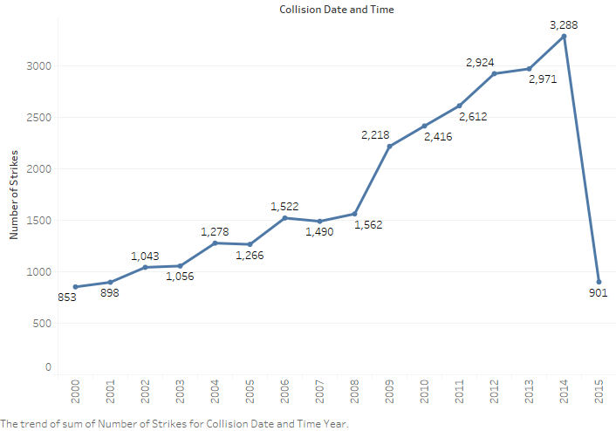

Now we can see that there is a drastic drop in the year 2015 but when investigate the data further we are able to see that the data we have is only till the month of May, i.e. only 5 months of the year thus we will not consider this value when analyzing the data on yearly basis. Further when we analyze this data we that there is a pattern in the data which is that the Quarter 3 of every year has the maximum number of strikes the quarter 3 include the months of July, August, September. When this is studied in more depth it could be seen that the month of August has the maximum strikes and then followed by the number of July followed by the month of September. Here is the glimpse of how this looks like when seen graphically. The reason for this pattern in the graph is that every year birds migrate to and from the US soils and this time period is the peak season for migratory birds to come and the US soil as this period has best weather conditions and perfect day lengths for birds to live thus the number of birds increase and hence this leads to most number of accidents.

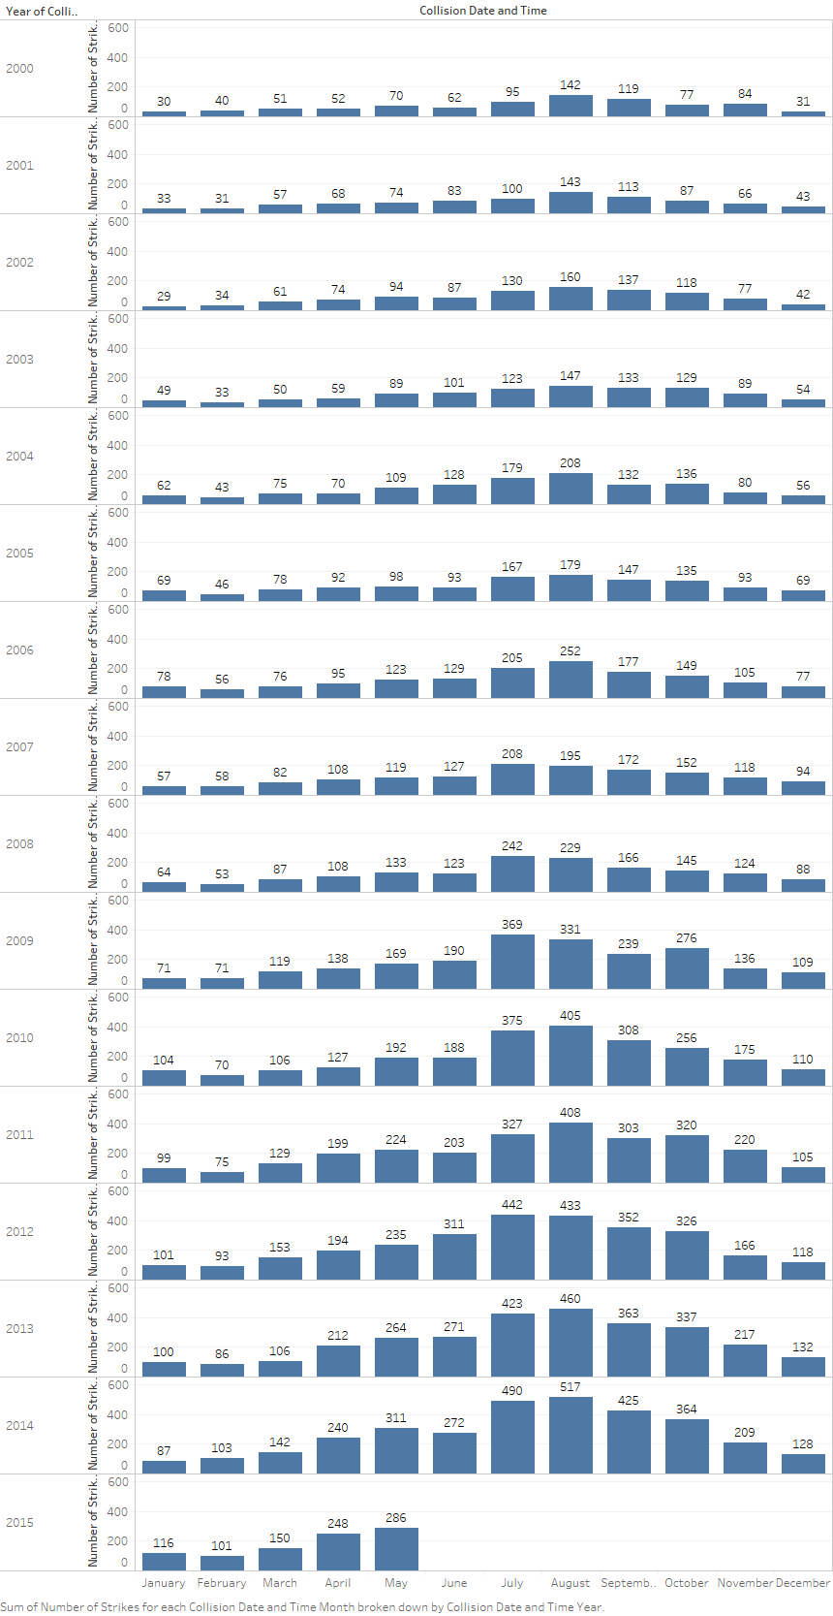

Now there are some factors that could be the reason of the increase with respect to that data that we have, Firstly, we know that there has been an increase in the number of people travelling by air as people are able to access more and more resources because they are getting rich hence they are able spend more, this increases the demand for the aircrafts hence the traffic increases. This is a major factor as more the number of aircrafts more are the chances for the miss-happening to take place. Another factor that could be the reason for increase is that people are now more aware about reporting such events, earlier people were not aware about this and more over we have seen that people mostly used to report these incidents on paper and not online, this explains that there may be the chance that in early years also accidents use to happen but were not reported but this is a mere idea as we don’t have any proof regarding this.

1. **Timing of Occurrence of Strike**

Most strikes happen in day time, this form 72.8% of the total number of accidents that took place. On the other hand, the accidents that happened at night time are just 17.41% that’s less than 30% of the accidents that happen in day time. The accidents that were reported to happen in dusk and dawn time are very less on the other hand there are some accidents whose time is not known.

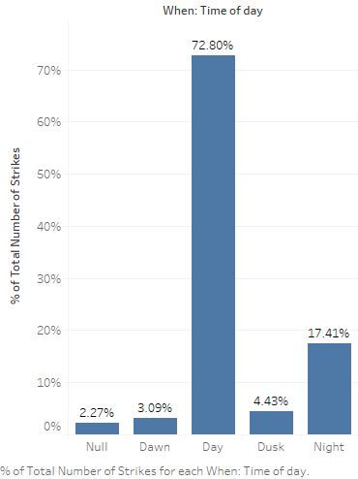

Now what is the possible reason for the number of strikes being more in day time is that the animals and birds are more active they are looking for food whereas, at night time most of the birds are sleeping. If we have a look at data in depth we can see that the number of accidents that happened at night time were involving the bats and terrestrial mammals. Birds and reptiles are major contributors for the day accidents.

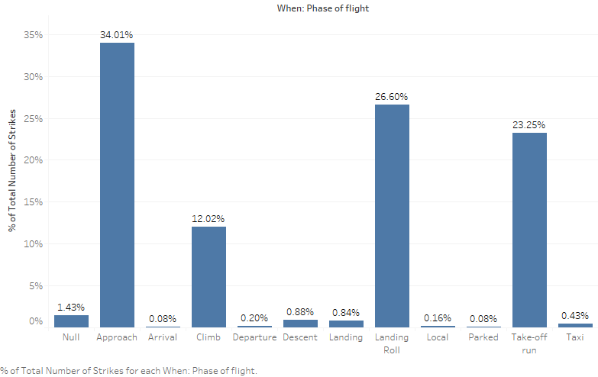

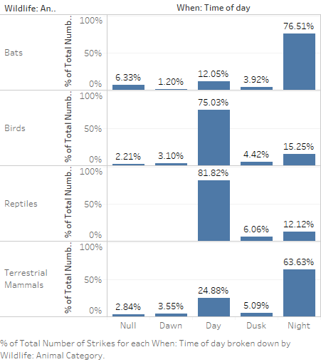 Another aspect that needs to be addressed in this section is that what was the phase of flight when the strike happened. It is seen that most strikes happen when the aircraft is in phase of Approaching, Landing-Roll or Take-off run. These three phases in total contribute to about 85% of total number of accidents. In all the three phases the aircraft is running on land at very high speed thus it is very dangerous situation. Now this brings up to another important factor that is height of the aircraft when the strike happened, the maximum height that has been reported is just 20000ft above the ground level which shows that most accidents happen near the airport as this is the only time when the aircraft is close to the land. Considering this, according to the data the accidents that took place within the distance of 19 miles on average.

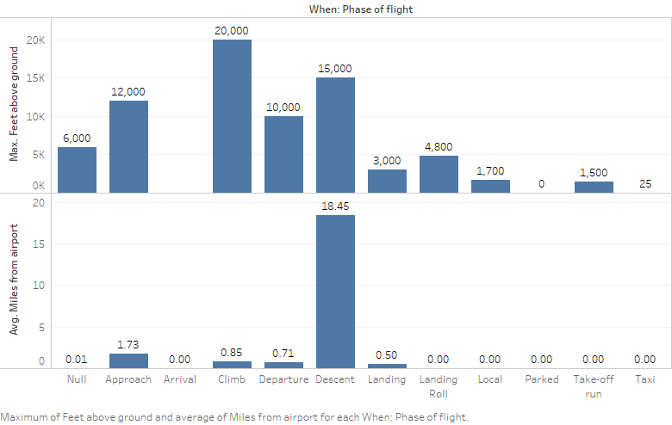

1. **Damage caused and Effect on Flight**

When we look at the effect of these strikes we see that almost 90% of the total strikes reported show that there was no damage done to the aircraft thus only 10% of the reported strikes reported damage out of which approximately 5% showed that the damages were minor. And mere 0.12% were destroyed now this seems that it is not a major problem because only few strikes result into big loss. But when these numbers are converted into finances these figures come out to be very drastic in the 15 years the strikes have resulted in the loss of 322 million dollars and this is a huge amount of money which has been lost only in repairing these damages. Here in the graph we can see that most of the money was spent in repairing the damages that were in substantial category

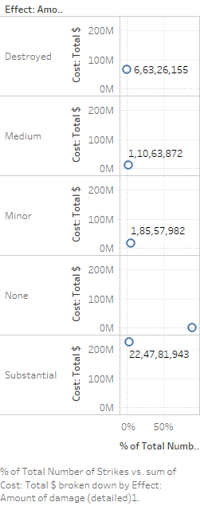. Now if try to study the expenditure there is another aspect to this as when an aircraft is damaged there is a time that the aircraft will not be able to fly and this in turn is the period that the aircraft will not be able to earn money for the owner hence this loss is not reported or calculated on average according to the data that we have the aircraft that is damaged is off the duty for approximately 200 hours that is approximately 8.5 days, i.e. loss of another 8 days thus a small animal can cause such a huge loss. Once the strike happened there were some cases that the flight was either aborted and in 5% of the total strikes a precautionary landing had to be done while in approximately 89% of cases there was no change in the flight schedule was made.

1. **Wildlife Species Involved**

Bird strikes cause huge damages to the aircrafts especially if the size of the bird is huge Canada geese is a huge problem for the aircrafts. But when we analyze our data we have found out that the number of strikes are maximum with birds then followed by the terrestrial mammals. When these categories are further studied then Morning dove is involved in maximum number of strikes.

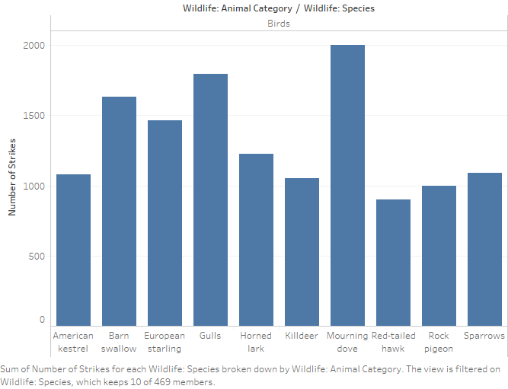

As we further study the wildlife categories in total we have data of 469 species which are broadly categorized in 4 categories when we analyze these categories in depth we see that in category bats the microbats have maximum number of strikes similarly when we have look at other categories like reptile’s turtles have maximum strikes but this number when compared to the number of strikes with Morning dove is just a 1/200. Where as in case of terrestrial mammals the number is of strikes is maximum for the coyote and white-tailed deer.

Here we are just considering the number of strikes when we see economical factor of this we see that the trends change. We see that the cost that had to be incurred to repair the damages was maximum for Canadian geese in the category of birds where as in the categories of terrestrial mammals white-tailed deer has maximum cost or repair but these numbers are the total spending over the years i.e. the duration of 15 years but when we try to analyze this from a different aspect we find a different result that is if we find the average cost incurred for each repair then the species are different Then in this case the repair cost was maximum for the terrestrial mammal wapiti(elk) and in category of birds the cost is maximum for American white pelican, these values cannot be trusted as these will differ in every case because the cost will be depend on how the strike took place if a heavy bird like geese is struck in engine the cost incurred will be different but if it strikes at a wind shield the cost incurred will be different. Thus to analyze the data we will consider the average values hence we find that the Canadian geese has been most damaging the reason is that the bird is heavy and due to its shape i.e. it is a huge bird as compared to small gulls despite their number of strikes being more the damage caused is less.

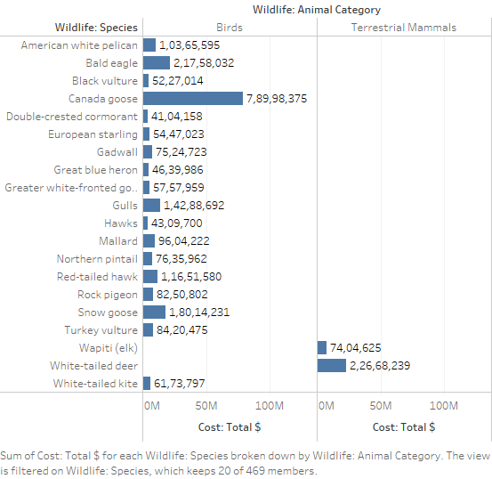

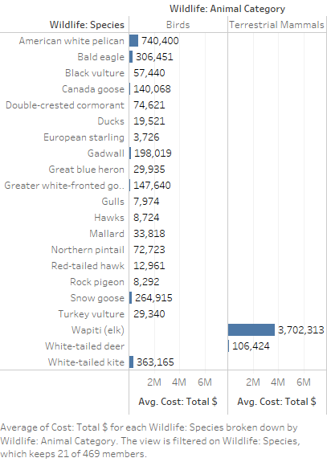

1. **Geographical analysis of Data**

The number of strikes when seen on the map the story is bit different we see that some congressional states have more number of strikes as compared to the number of strikes that took place in others thus we find out that the California has maximum number of strikes that have been reported over the given period of 15 years.

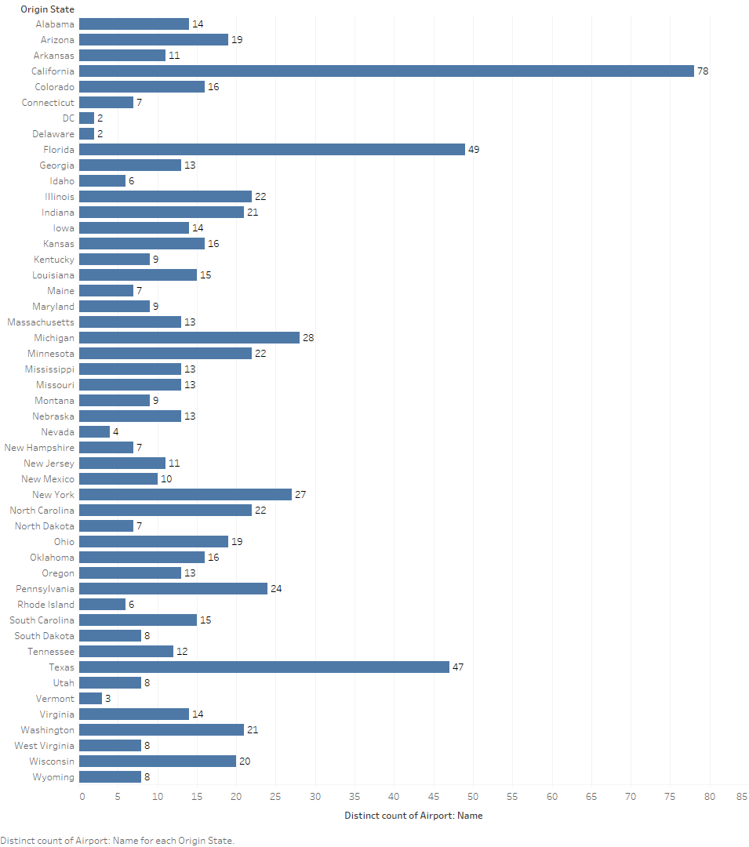

The data that we have is for 711 airports and out of these 78 are in California, 49 are in Florida and 47 in Texas. Whereas, the number of strike that took place are also in same order. This could be one of the reason that the states with more number of airports has more wildlife strikes. But this could not be true in all cases that is if we see the complete list and we see that DC has only two airports that have been taken into consideration for the data analysis but it has reported 410 strike incidents thus it breaks out the pattern that suggest that more the number of airports more are the number of strikes.

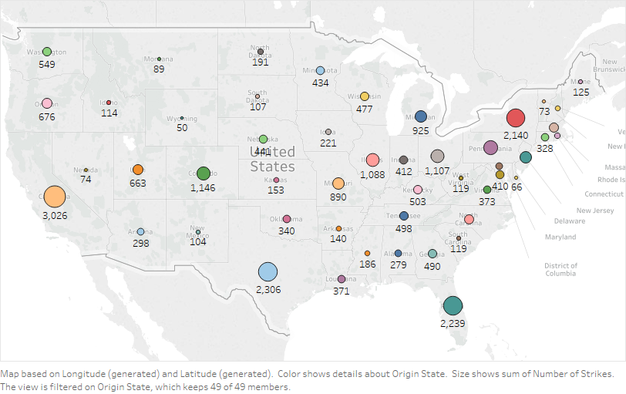

There is a geographical aspect to number of strikes being high in these regions is that the states lie towards the south and these areas have a huge number of migratory birds that increases the number of birds in the area in the month of August and September. Thus, we can see that the number of strikes is high.

1. **Discussion**

Now after we have completely analyzed the data we have come across some problems and now we will try to discuss all the aspects in one picture. We know that these wildlife strikes are dangerous and costly not only do they cost in money but also in time these disrupt the schedules if something major happens thus in a bigger picture everyone involved with the working of the flight has to devote extra time to solve the problem from an engineer to a flight attendant everyone has to put in extra effort and this ultimately is cost that has to be paid by the airlines. Now when we found out that most of these strikes take place within 20 miles of the airport this could be very dangerous in the cases where the airports are within the city or are close to the seashore. As in the past there have been happening where these strikes turned out to be fatal for example in this incident that took place on January 4, 2009, a Sikorsky S-76 helicopter hit a red-tailed hawk in Louisiana. The hawk hit the helicopter just above the windscreen. The impact forced the activation of the engine fire suppression control handles, retarding the throttles and causing the engines to lose power. Eight of the nine persons on board died in the subsequent crash; the survivor, a passenger, was seriously injured [3]. Thus, we must consider this problem and look for the counter measures. Moving ahead we have seen that the birds and animals that have large body structure and are heavy in weight are causing more damage for very basic reason that these strike when happen there is a simple formula of kinetic energy which 1/2mv^2 this shows that mass is directly proportional to energy and so is the velocity with which the bird is flying when the bird strikes the plane thus the force produced during strike with large animals at huge speed of aircrafts produces more dangerous effect.

1. **Forecast**

Now, if we try to find out the future regarding the number of wildlife strikes that can happen in the coming years we see that there is an increase in the number and this curve has increased drastically after the year 2008. The blue shaded region shows the extent to which the value can vary and the blue solid line shows the average if the estimated values. The method used for future generation is called exponential smoothing used by the data analysis tool tableau. The predictions made show that the value of number of strikes will cross the 4000 mark for the year 2017, same is the scenario when we predict the number on monthly or quarterly bases the thus the trends are similar to what has happened in past that is the value in month of July, August and September is shown to be highest when compared with all others months in the year.

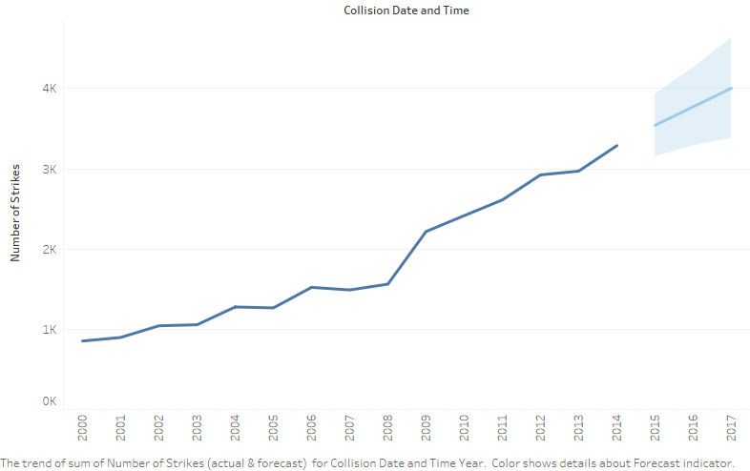

The reasons that could lead to the number of accidents increasing over the years can be seen from two perspectives firstly, with time there is increase in the population there are more number of people who want to travel by air as this is the fastest means of transportation thus

1. Thorpe, John (2003). ["Fatalities and destroyed civil aircraft due to bird strikes, 1912–2002"](http://www.int-birdstrike.org/Warsaw_Papers/IBSC26%20WPSA1.pdf) (PDF). *International Bird Strike Committee, IBSC 26 Warsaw*.
2. Edward C. Cleary, Richard A. Dolbeer, and Sandra E. Wright. Wildlife Strikes to Civil Aircraft in the United States 1990-2005.\
3. [*"Brief of accident; Sikorsky S-76C aircraft registration N748P"*](http://dms.ntsb.gov/aviation/AccidentReports/huslbw55zsht4kfzewb1qu551/T05022012120000.pdf) (PDF). National Transportation Safety Board. 2010-11-24*. Retrieved May 2, 2012*